WORKSHEET 3
Student Name: Aradhya Sharma UID: 25MCC20042
Branch: MCA (CCD) Section/Group: 25MCC-101A
Semester: 2 Date of Performance: 27 JAN 2026

Subject Name: Technical training Subject Code: 25CAP-652

- AIM:
implement conditional decision-making logic in PostgreSQL using IF–ELSE constructs and CASE expressions for classification, validation, and rule-based data processing.

- OBJECTIVES:
- To understand conditional execution in SQL
- To implement decision-making logic using CASE expressions
- To simulate real-world rule validation scenarios
- To classify data based on multiple conditions
- To strengthen SQL logic skills required in interviews and backend systems

SOFTWARE REQUIREMENTS
To perform this experiment, the following software is required:
- Operating System
  - Windows 10 / 11, Linux, or macOS
- Database Management System (DBMS)
  - PostgreSQL (version 12 or higher)
- SQL Client / Interface
  - pgAdmin 4 (for PostgreSQL)
OR
  - Command Line Interface (psql)

- PROCEDURE FOR EXPERIMENT
Step 1: Database and Table Preparation
CREATE TABLE violation_schema (
schema_id INT PRIMARY KEY,
schema_name VARCHAR(20),
violation_count INT
);

INSERT INTO violation_schema (schema_id, schema_name, violation_count) VALUES
(1, 'Customer_Schema', 0),
(2, 'Security_Schema', 2),
(3, 'Product_Schema', 5),
(4, 'Project_Schema', 1),
(5, 'Operation_Schema', 0);

Output:

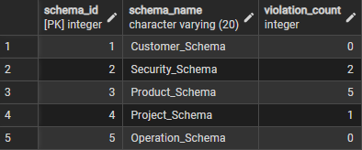

Step 2: Classification of data using case

SELECT
schema_name,
violation_count,
CASE
WHEN violation_count = 0 THEN 'No Violation'
WHEN violation_count BETWEEN 1 AND 2 THEN 'Minor Violation'
ELSE 'Critical Violation'
END AS violation_Status
FROM violation_schema;

Output:

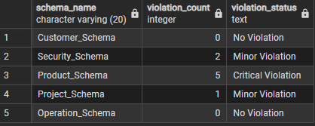

Step 3: Applying CASE Logic in Data Updates

-- Add new status column
ALTER TABLE violation_schema
ADD COLUMN status VARCHAR(30);

-- Update violation status
UPDATE violation_schema
SET status =
CASE
WHEN violation_count = 0 THEN 'Approved'
WHEN violation_count BETWEEN 1 AND 2 THEN 'Needs Review'
ELSE 'Rejected'
END;

Output:

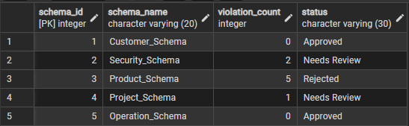

Step 4: Implementing IF–ELSE Logic Using PL/pgSQL

DO $$
DECLARE
violation_count INT := 5;
BEGIN

IF violation_count = 0 THEN
RAISE NOTICE 'Approved';
ELSIF violation_count BETWEEN 1 AND 2 THEN
RAISE NOTICE 'Needs Review';
ELSE
RAISE NOTICE 'Rejected';
END IF;
END $$;

Output:

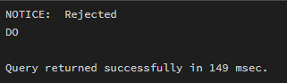

Step 5: Real-World Grading System (Classification Scenario)

CREATE TABLE StudentGrades (
uid INT PRIMARY KEY,
student_name VARCHAR(50),
marks INT
);

INSERT INTO StudentGrades (uid, student_name, marks) VALUES
(1, 'Hanna', 85),
(2, 'Jatin', 32),
(3, 'Gourish', 68),
(4, 'Vansh', 71),
(5, 'Akash', 56);

Output:

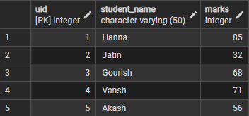

Step 5.1: Classify Students Using Conditional Logic
SELECT
student_name,
marks,
CASE
WHEN marks >= 90 THEN 'A+ Grade'
WHEN marks BETWEEN 80 AND 89 THEN 'A Grade'
WHEN marks BETWEEN 70 AND 79 THEN 'B Grade'
WHEN marks BETWEEN 60 AND 69 THEN 'C Grade'
WHEN marks BETWEEN 40 AND 59 THEN 'D Grade'
ELSE 'Fail'
END AS Grade
FROM StudentGrades;

Output:

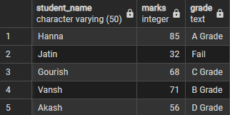

Step 6: Using CASE for Custom Sorting
SELECT
schema_name,
violation_count,
CASE
WHEN violation_count > 5 THEN 'Critical Violation'
WHEN violation_count BETWEEN 3 AND 4 THEN 'Moderate Violation'
WHEN violation_count BETWEEN 1 AND 2 THEN 'Minor Violation'
ELSE 'No Violation'
END AS violation_status
FROM violation_schema
ORDER BY
CASE
WHEN violation_count > 5 THEN 1
WHEN violation_count BETWEEN 3 AND 4 THEN 2
WHEN violation_count BETWEEN 1 AND 2 THEN 3
ELSE 4
END;

Output:

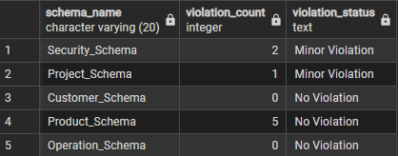

Learning Outcome
This experiment demonstrates how conditional logic is implemented in PostgreSQL using CASE expressions and IF–ELSE constructs.
Students gain strong command over rule-based SQL logic, which is essential for:
- Backend systems
- Analytics
- Compliance reporting
- Placement and technical interviews

